Question – 1. Discuss some misconception of WTO. (with examples and critical discussion is expected) The current stalemate in the WTO is an impression of the strength of non-industrial nations, not their lack of interest. Agricultural nations are an awe-inspiring phenomenon. They can arrange. They are actually able. They are coordinated. While they are and have been numerous dangers of an unreasonable arrangement being forced on non-industrial nations, this danger ought not reason them to repudiate their genuine cases to a reasonable and adjusted result in the Doha Round. They have demanded that the guarantee that the Doha Round will be an advancement round ought to be satisfied. Alternatively, WTO has rules which favor multinationals. For instance, 'most preferred country' rule implies nations should exchange without separation. This has benefits however can mean non-industrial nations can't offer inclination to nearby workers for hire, yet may need to pick unfamiliar multinationals.
Question – 2. 5 points
Suppose that US economy in recession, explain the effect of the recession in the nominal exchange rate (Canadian perspective): draw a graph of the foreign exchange market, demand & supply of US dollars, with exchange rate on the vertical axis (as discussed in the lecture). Does Canadian dollar appreciate or depreciate? An appreciation for the Canadian dollar, by changing the overall costs of homegrown and unfamiliar items, prompts replacement in spending. 11 Both Canadian and unfamiliar purchasers substitute away from the generally more costly Canadian merchandise and enterprises, and towards the moderately more affordable unfamiliar items. At the end of the day, by changing worldwide relative costs, the enthusiasm for the Canadian dollar prompts a lessening in Canadian fares and an expansion in Canadian imports.
The Canadian dollar appreciates.

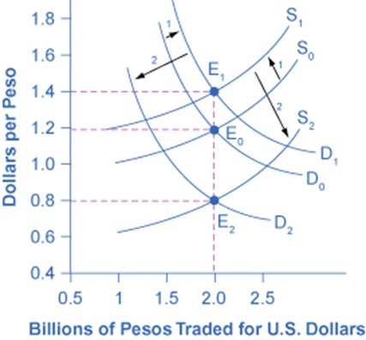
Question – 3. Answer the Following questions: 8 points
- If foreign countries cut their interest rates then what will happen to the capital inflow in Canada (show with diagram)? 2points, the capital inflow will expand prompting a theoretical air pocket in the securities exchange. One unwanted result of such an air pocket is commonly a decrease in the nearby reserve funds rate, as people find that their resource gathering goals are being accomplished without the requirement for anything so dreary as keeping away from utilization. Another unfortunate result can be a monetary emergency, and the threat of a downturn, when the air pocket blasts.
- 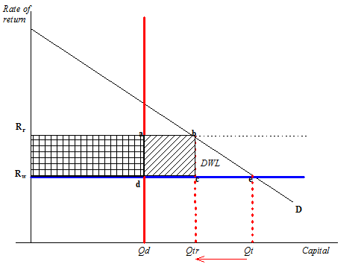
- If US citizens buy Canadian bonds then what will be the impact on the Canadian currency. 1pt When the US citizens buy Canadian bonds this means that the money from individual banks will flow to the central bank hence reducing the quantity of the Canadian currency.
- Where does the supply of US$ in the Canadian foreign exchange market come from? 1pt
The supply of US$ in the Canadian foreign exchange market comes from exchange of goods and services from Canada as a domestic country to United States as a foreign country welcoming the dollar to the domestic country.
- If the Canadian dollar is pegged against the U.S. dollar, and the Japanese Yen depreciates against the U.S. dollar, what will happen to Canada? 1pr The Canadian dollar will appreciate against the Yen, since the US dollar appreciated against the Yen so does the Canadian dollar.
- Suppose it costs C$1.2 to buy one US$, and the price level or index in the US is 115. The price level or index in Canada is 112. What is the real exchange rate from Canada’s perspective? 2pt
index in the US =115, price level index in Canada is 112,115-112/100=0.03+1.2=1.23

Question - 4. 8 points
Real Exchange Rates, Nominal Exchange Rates, and Net Exports:
Suppose that in 1996, the price levels in United States and Canada were 100. By 2000, the price level in United States has increased to 230, while the price level in the Canada rose to 220. Suppose the exchange rate between two countries in 1996 was $1USD = $1.7CAD
(a) What was the 1996 real exchange rate? 1point
1*100/100
(b) What must the new nominal exchange rate have been in 2000 if the real exchange rate remained constant? 2points
1=e*150/200=1.333
(c) Suppose, United States has a fixed exchange rate system against the Canadian dollar. The initial nominal exchange rate is fixed. As a result, did Canada’s real exchange rate appreciate or depreciate? 2points
The Canada’s real exchange rate appreciated.
(d) Would you expect Canada’s net exports to rise or fall as a result? (Explain how) 2points
I expect the Canada’s net export to fall as a result since the initial nominal exchange rate is fixed, then it will prefer dropping it export rate while increasing the importation rate to survive in that economic situation.
(e) Is the Canadian dollar overvalued or undervalued? 1point
The Canadian dollar is undervalued since we can see that its net export has fallen.
Question - 5. 2 points
Suppose you can invest $2,000 Canadian for a year. Canadian one-year interest rates are 3 percent. In the United States one-year rates are 4 percent. The higher United States rates look attractive.
If you keep your funds in Canadian dollars (invest in Canada), how much money will you have at the end of the year?
1 year=3% I.r
$2,000*3/100=$6000/100=$60
Then, $2,000+$60=$2060
So, by the end of the year you will have $2,060
If the exchange rate is $1.03Cdn/$1US then can you do better by buying a United States asset?
Yes, I will do better by buying a United States asset.
What would be your decision if exchange rate becomes $1.009Cdn/$1US, would you buy US asset?
Here my decision is that I will prefer buying Canadian assets rather than the United States assets since the exchange rate has reduced the quantity of money am holding.

